PHP Tutorial – updating database records part 2

In this tutorial, we are going to improve on the approach to updating database records via a web interface used in the last tutorial to create a much more user-friendly system.

Before doing this tutorial you should have done the newnumyspace, forms, and the previous PHP tutorials and should have already created the MySQL database tables film and film_category (if not, you will need to do that now by downloading the film.sql file from blackboard and uploading it to phpMyAdmin)

- the film table’s fields are filmID, title, categoryID and notes
- the film_category table’s fields are categoryID and categoryName

In the following exercises remember that you will then need to upload copies of each file you create onto your web space on the newnumyspace web server and that to test them you need to enter the appropriate web address into the address bar of your web browser.

Exercise 1: choosing a record to update from a list
In this exercise, we will create a script that displays a list of all of the films in the film table from which the user can select a film to update.
There a lots of film records in the film database table. One way of helping the user select the right one to update is to display the films in such a way so that you can show fields like the title and category. We can then make each title a link to an edit form, say editFilmForm.php and pass, in the link, the filmID, e.g.:
<a href='editFilmForm.php?filmID=1'>Australia</a>
So, create a new PHP script called chooseFilmList.php (remembering as always to use the basic HTML core tags as a basis) and implement that. It should use PHP to query the database and dynamically create a list all the films making the title a link as shown above. For each film, in addition to the title, also display the category.  When viewed in a web browser the page generated should look something like the image on the right (you could of course use some CSS to improve the layout etc.). | 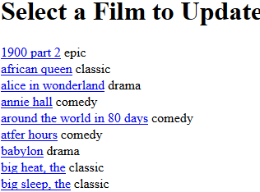

Hints:
- In pseudo code I would:
- display html header elements (<!doctype html><html ...> etc.)
- connect to the database
- query the film table using an SQL query to retrieve all of the records in the table
- loop through the query results, and for each iteration (record) generate one hyperlink whose href points to editFilmForm.php that passes the filmID for the record in a query string. Each hyperlink should look something like the following:

<a href='editFilmForm.php?filmID=1'>Australia</a>

Exercise 2: create a web form to update the record with
Create a new PHP script (remembering to use the basic HTML core tags as a basis) called editFilmForm.php that will receive the filmID from the query string sent via the hyperlink clicked in chooseFilmList.php and then use that filmID as part of an SQL query to retrieve all the field values for the relevant record from the film table. You should then use those field values in a form so that the user can edit them. Note that for this exercise it is OK to display the category ID. Later we will improve things by displaying the current category name as the default value in a select list instead.  The form should look something like the image on the right. | 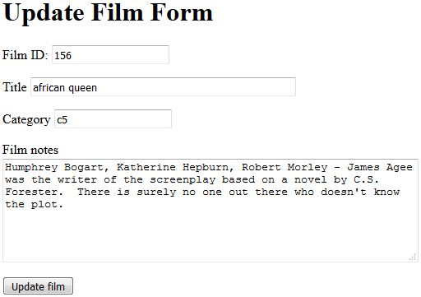
Note: in the example shown above the user could actually modify the film ID. Would you want to allow the user to be able to do this? If not, why not and what could you do to prevent this?
Hints
- In order to put a value into the form when it's first loaded assign it to the value attribute of an <input> tag, e.g.:
echo "<input type='text' name='title' value='{$rowObj->title}'>";
Where the value of $rowObj->title is that of the title field retrieved from the database
- This form will need to call another script to actually update the database - so make its action equal to updateFilm.php
- In pseudo code I would:
- display html header elements (<!doctype html><html ...> etc.)
- start a form whose action is equal to updateFilm.php
- connect to the database
- get the filmID from the request stream
- use the filmID in a WHERE clause to retrieve all the film details
- use the values of the fields retrieved from the database as the values of the form’s input boxes (one each for filmID, title, categoryID and notes), as above for title
- include a submit button
- end the form

Exercise 3: create a script to update a record
- Now you will need to create a script called updateFilm.php that the form you created for exercise 2 calls as its action. This script will execute appropriate sql to update the record being edited.

In pseudo code I would:
- display html header elements (<!doctype html><html ...> etc.)
- connect to the database
- get all the data from the request stream into variables
- assign a sql update statement to a variable. Remember to use the filmID in a WHERE clause so only one record is updated
- Execute a query using the variable containing your sql
- Display a message if the query executed without error
- Display a link back to the page you created in exercise 1.

- Add PHP code to
  - prevent undefined index errors
  - prompt the user to enter values for any form fields they may have left blank after editing
  - escape any special characters that may have been entered in the form
  - only update if values for all form fields were provided.

Exercise 4: default values and deleting a record
- Displaying default values - modify editFilmForm.php so the form initially displays the current category name as the default value in a select list to help the user choose different values if they wish. The select list should be dynamically generated from database content and should have one option for each of the categories in the film_category table. The category ID should not be displayed.
- Delete a film record
  - create a version of chooseFilmList.php that allows the user to click on the title of a film that they want to delete from the database
  - when a title is clicked the href needs to point to a php script called deleteFilm.php that passes the filmID for the record in a query string
  - deleteFilm.php should use the basic HTML core tags as a basis. It needs to delete a film record from the film table of your MySQL database. It should:

    - Connect to the database
    - Delete the film record with the filmID included in the query string
Tip: Remember to construct the required sql query and execute it but with a delete command, like the update one. It is very important to get the WHERE clause correct, else you can delete all records in the entire table.

    - Output a message to the web browser to indicate that the record has been deleted, you might also want to give details about which record it was.

  - Check that the film record was deleted.

